How to register for an event
Go to Akron Chapter website: http://akron.imanet.org/home
Use the “Upcoming Events” section or the “Events & Education -> Chapter Events” links.
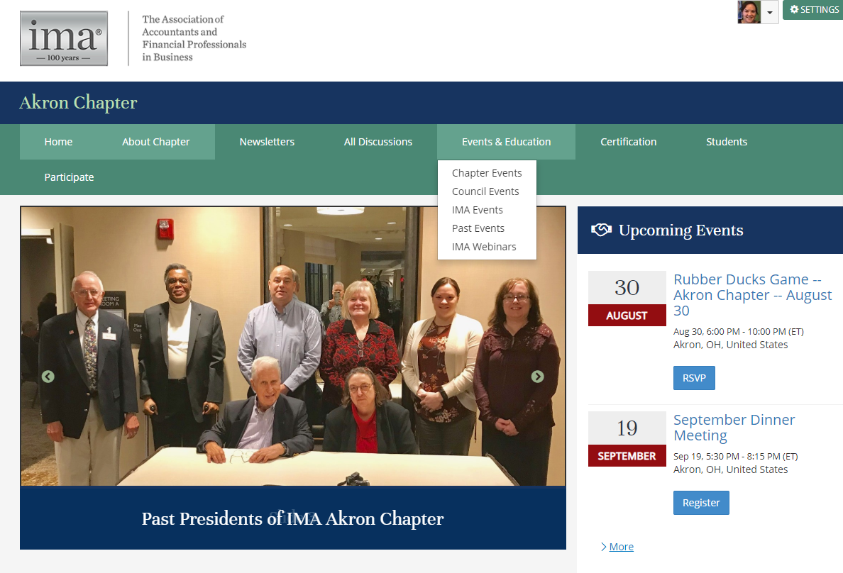
After selecting your event, click “Register Now”
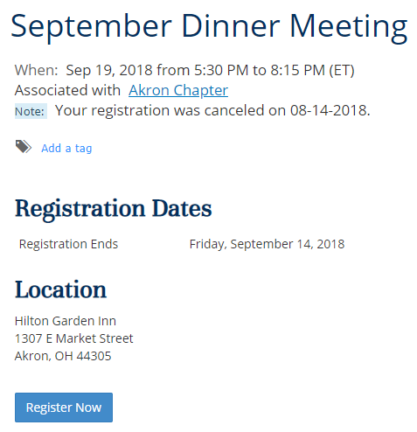
Select that you are registering yourself and others. Add a new contact If this is the first time you are bringing your guest. Use the search feature if this is a repeat guest.
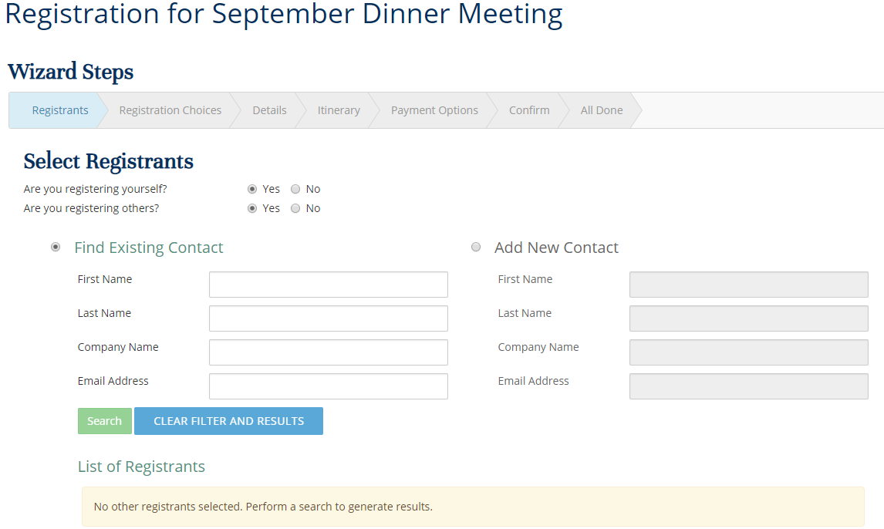
The next screen shows the search functionality:
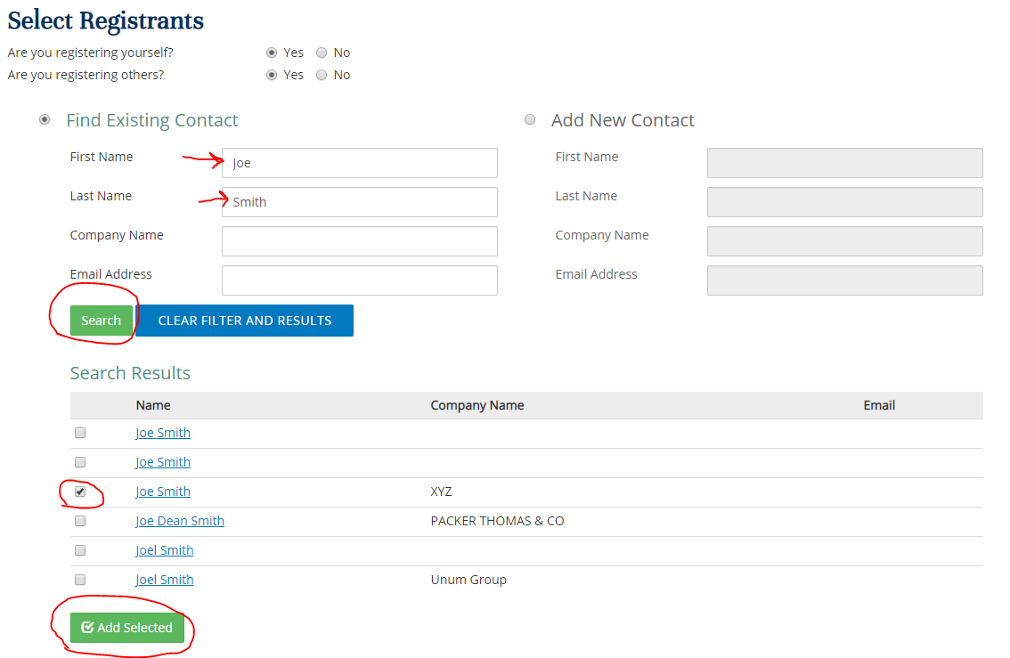
Joe Smith from XYZ Corp has been added:
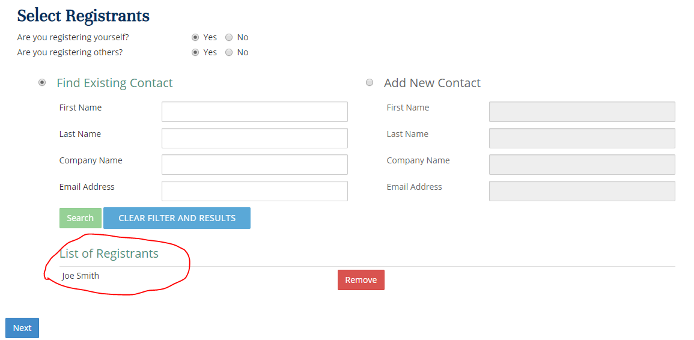

If you are an IMA member, your pricing should correct show as $25 for dinner ($10 if you are a student). It is always $0 if you are not having dinner. This first step is for the person registering (not the guest, that will come later).
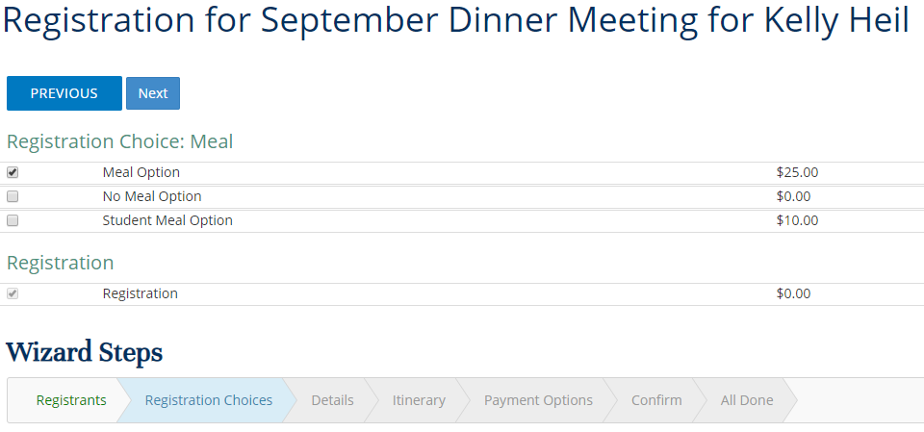
Please let us know if you need anything (vegetarian meal, etc):
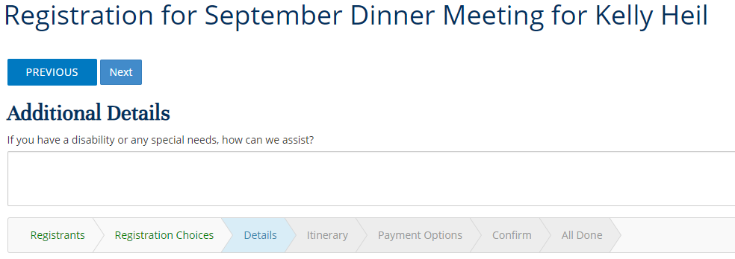

Let us know if your guest needs anything:
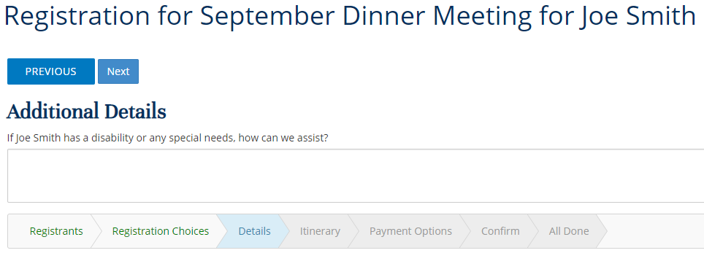
This is an information message saying that the dinner option will also be selected for your guest:
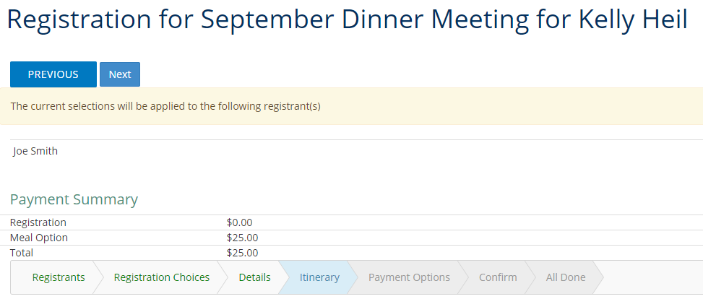

Your pricing should be complete. This assumes that Joe Smith is not an IMA member (since he was entered manually) and that he is having dinner. If you need to adjust the dinner option, click on his name.
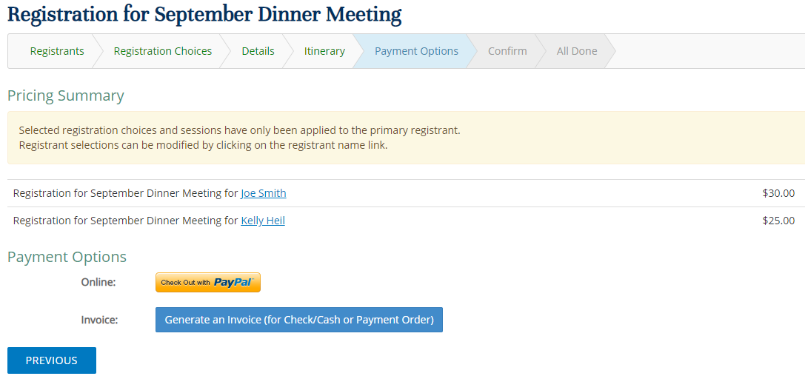
You can select the meal, no meal, or student pricing (if applicable). Joe Smith is not a member so he does not qualify for member pricing.
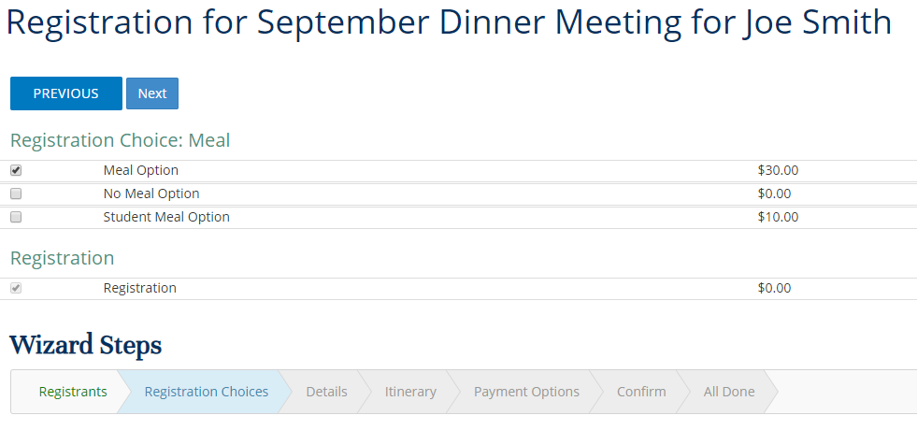

You can pay through PayPal or generate an invoice if you are paying on site.
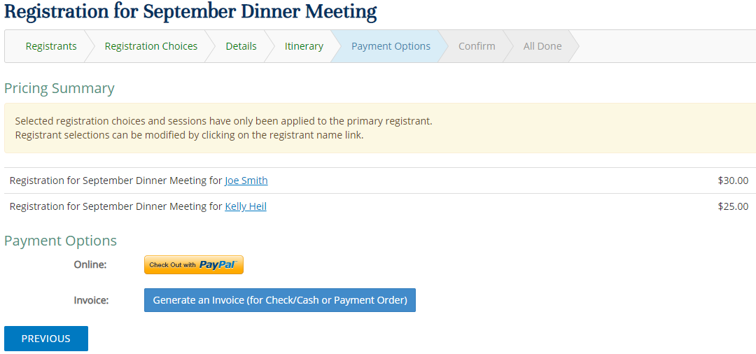

Registration complete!
