How to re-subscribe to community emails:
On the Akron Chapter homepage, once you are logged in, there is a small icon with a down arrow (drop down box).
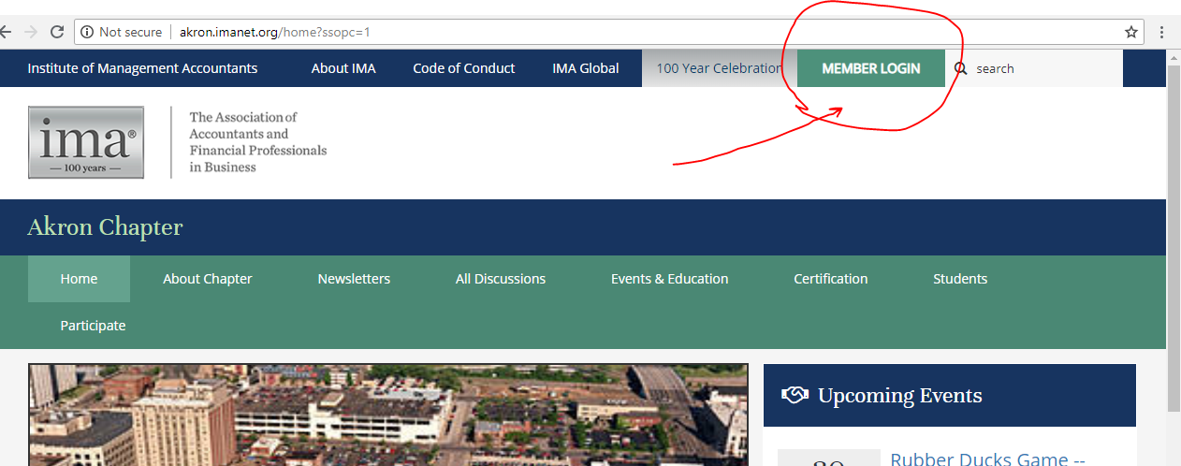
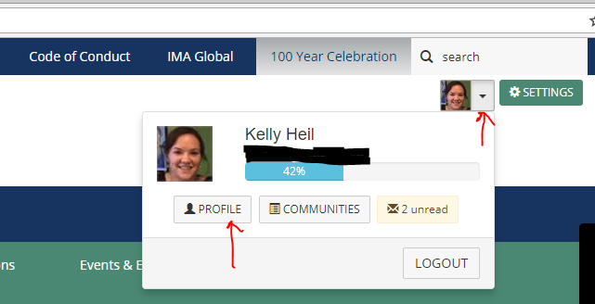
Click on the arrow and it opens a menu. Click Profile. Under your name, there is another menu. Click My Account on the far right and select Email preferences.
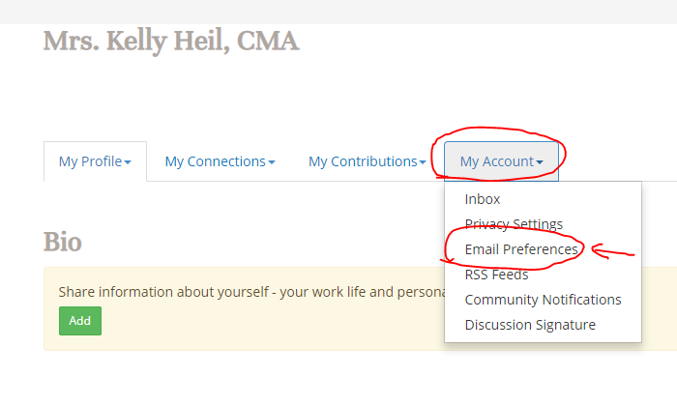
You should be able to turn your emails for the community back on.
