How to register for an event
Go to Akron Chapter website: http://akron.imanet.org/home
Use the “Upcoming Events” section or the “Events & Education -> Chapter Events” links.
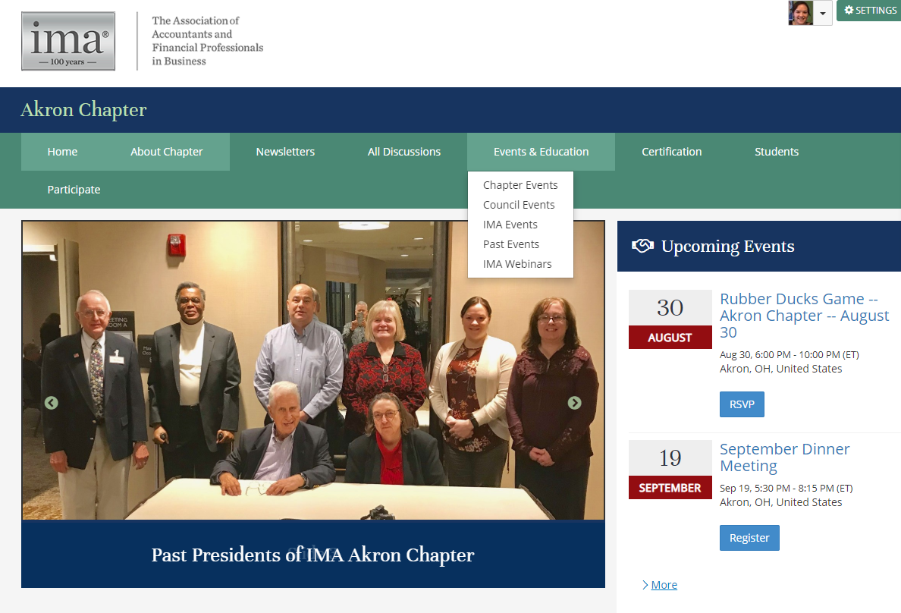
After selecting your event, click “Register Now”
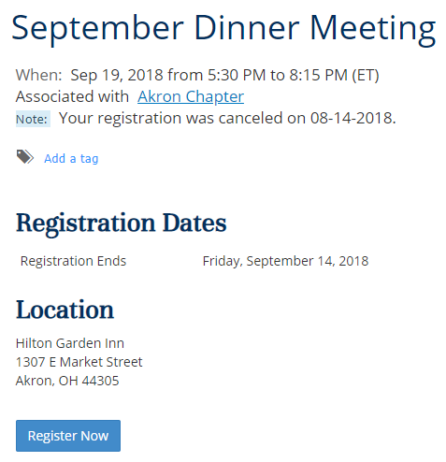
Select that you are registering yourself. Please see document for additional registrations if you are bringing a guest.
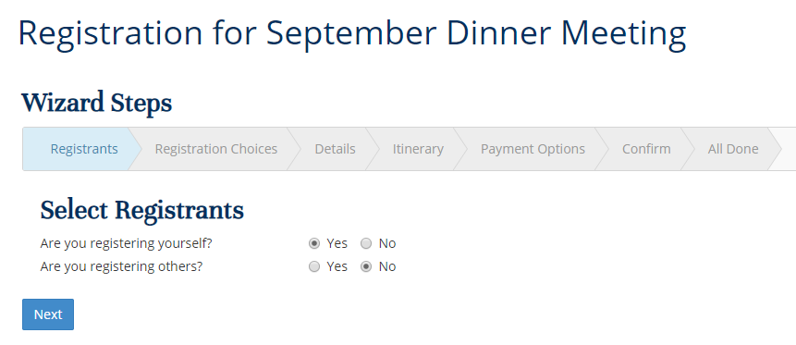
If you are an IMA member, your pricing should correct show as $25 for dinner ($10 if you are a student). It is always $0 if you are not having dinner.
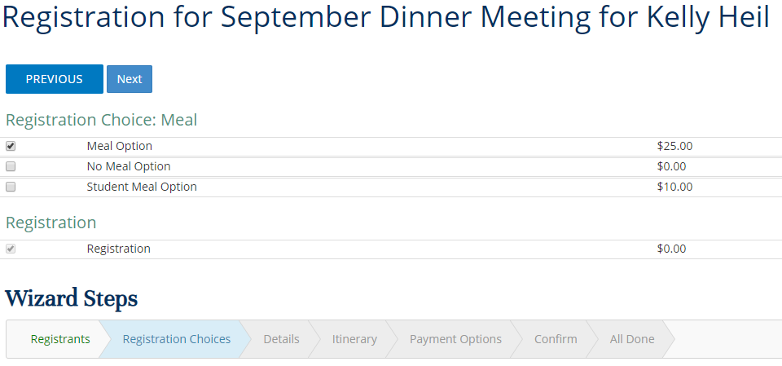

Please let us know if you need anything (vegetarian meal, etc):
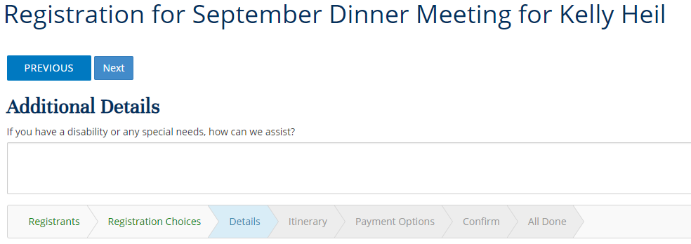
Your pricing should be complete:
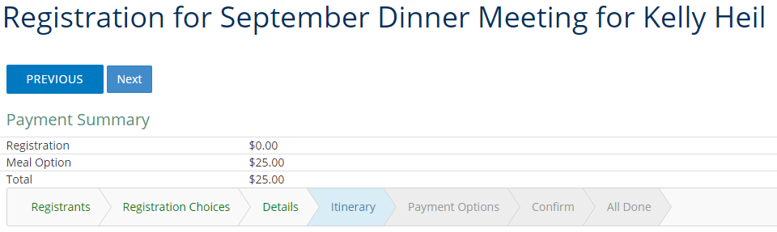
You can pay through PayPal or generate an invoice if you are paying on site.
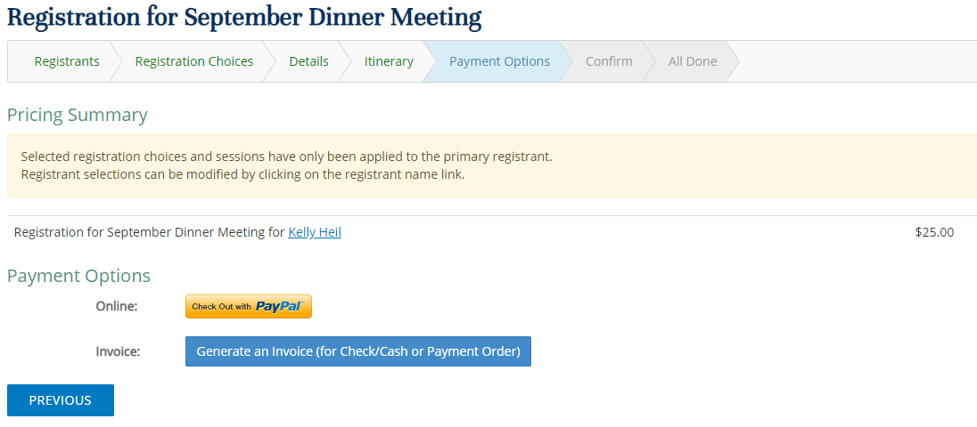

Registration complete!
