How to download the Chapter Roster
Go to akron.imanet.org and log in:
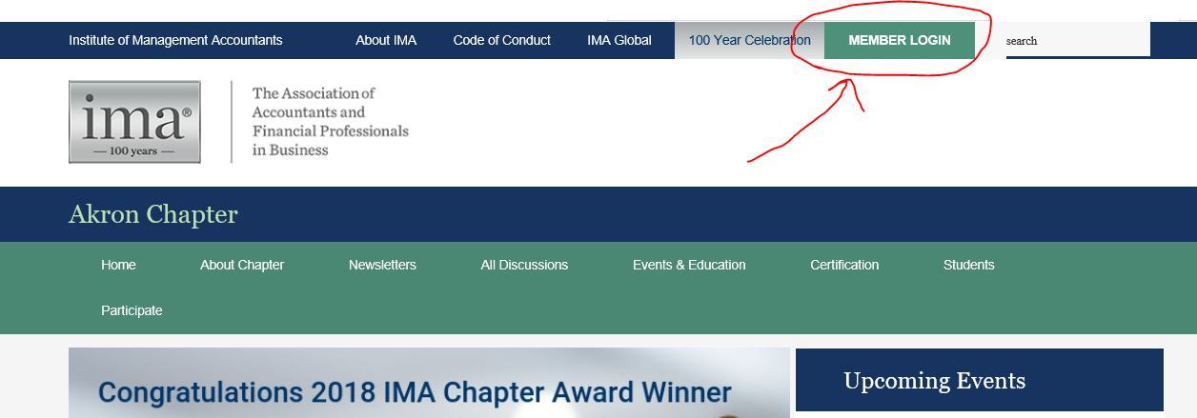

Enter your IMA member ID and password:
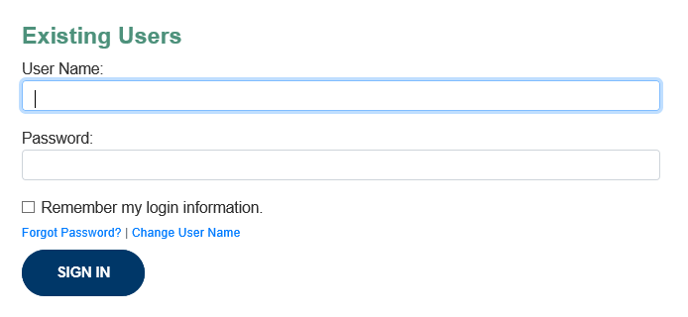
Go to “About Chapter” and then “Chapter Directory”:
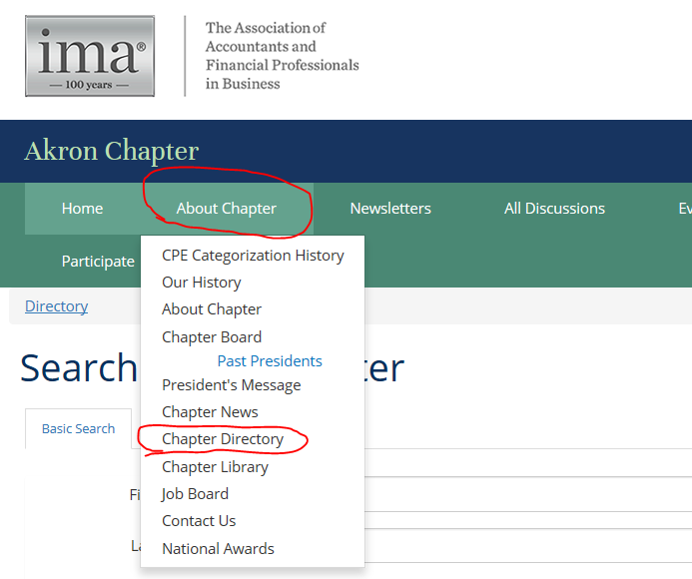
Type in a specific person that you want to find and click “Find Members”:
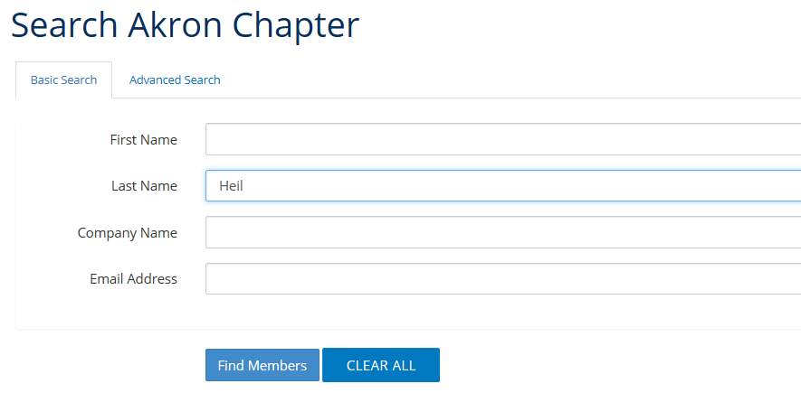
Search results will show the person and give you the option to export as a csv/Excel file.

Go back to the search options page and leave all fields blank. Click “Find Members” again:
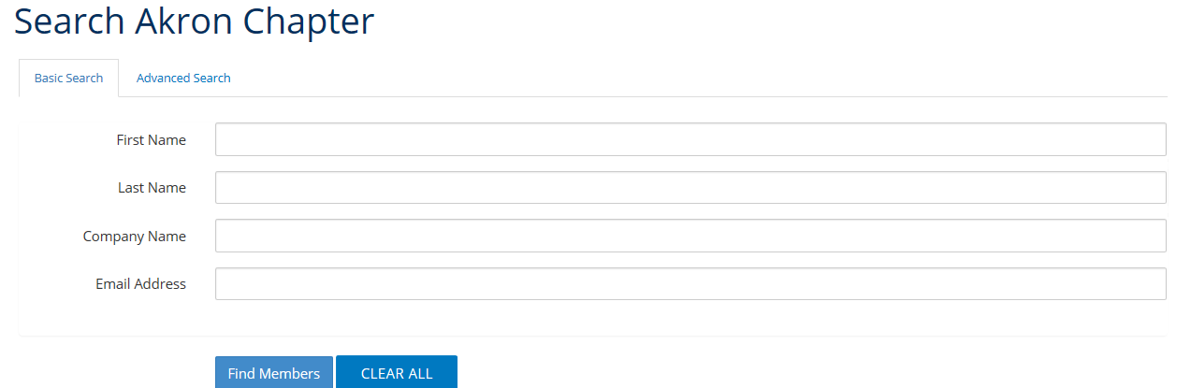

ALL members show in the list. Click Export to retrieve list:
