How to email a community member:
Go to akron.imanet.org and log in:
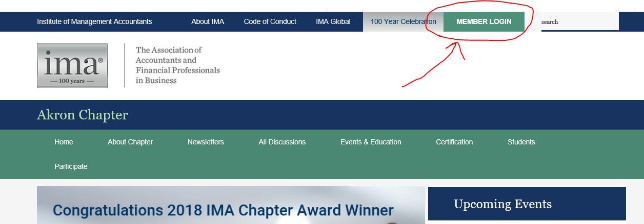

Enter your IMA member ID and password:
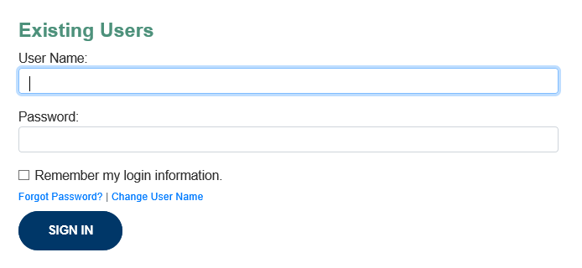
Go to “About Chapter” and “Chapter Directory” to search for a person to email:
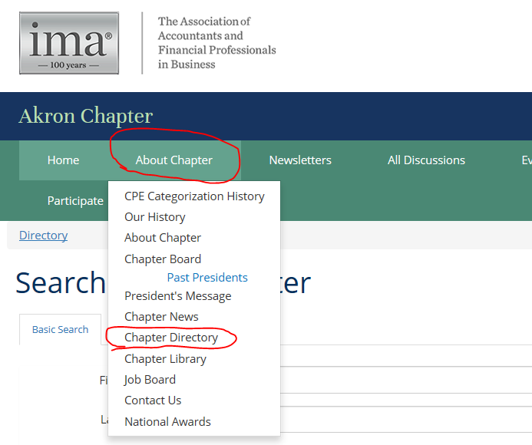
Type in a specific person that you want to find and click “Find Members”:
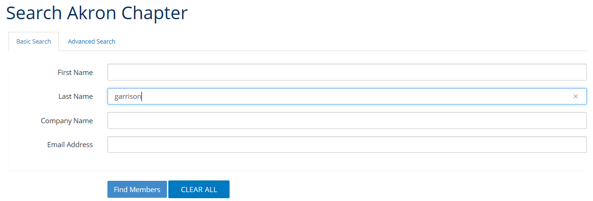
Click “Send Message” next to the person you want to send a message to:
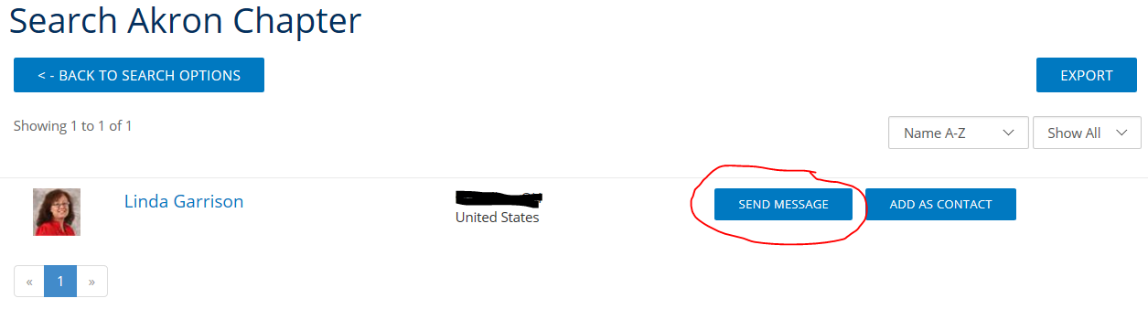
Type message and click “Send”:
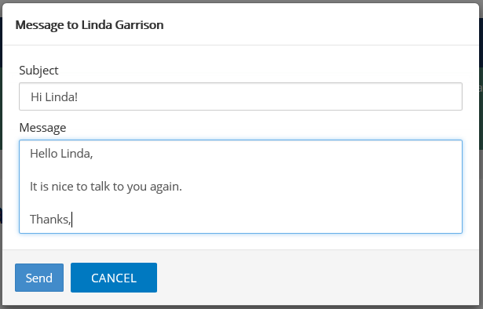
Email sent to you can be found at the top of the page, under your photo:
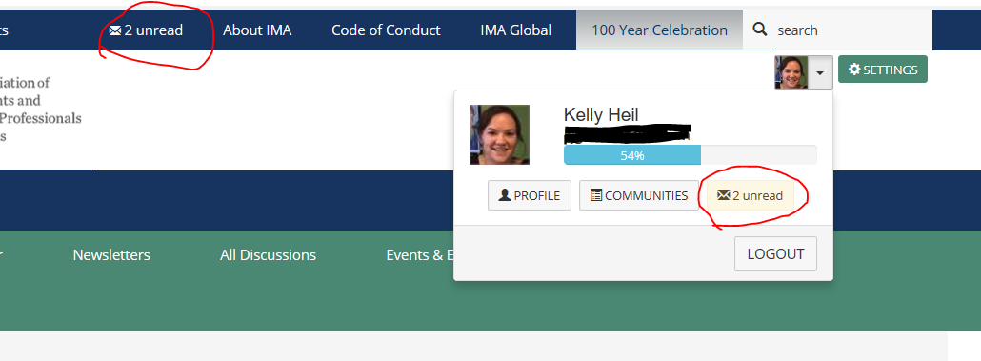

Click on the email you want to open!
